What is vocal cord dysfunction?

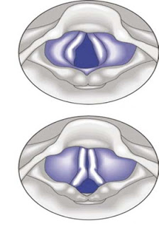
- Vocal cords are folds of tissue that stretch across your voice box. As you breathe in, your vocal cords open to let air go through into your lungs, then narrow as you breathe out.
- If you have vocal cord dysfunction, your vocal cords suddenly close when they’re not supposed to, cutting off your air supply.
  - Often this happens during exercise or when you’re emotionally upset or crying – just when you need air the most!
  - Other triggers include colds, strong odors or fumes, tobacco smoke, post-nasal drip and acid reflux (GERD).

Separating the symptoms from asthma

- Vocal cord dysfunction is often mistaken for asthma. This is no surprise, since symptoms of the two conditions are so similar. There are some differences, however, that you might notice.

 | Vocal Cord Dysfunction | Exercise Induced Asthma
Timing of Symptoms | Less than 5 minutes after beginning exercise | 5-10 minutes or more after beginning exercise
Tightness | In throat | Middle or lower chest
Wheezing or high-pitched sound | When breathing in; hoarse voice | When breathing out
Recurrence | Symptoms can recur immediately and more severely when exercise resumes | Symptoms tend to be less severe when exercise resumes (after bronchodilator use)
Recovery time | May takes less than 10 minutes | Usually takes up to an hour without medication
Medications | Bronchodilator (Albuterol) won’t help | Bronchodilator (Albuterol) will help

Treatment of vocal cord dysfunction

Caption describing picture or graphic.
- Relaxed Throat Breathing
  - Technique:
    - Sit with hand on abdomen
    - Inhale into the abdomen — abdomen goes out
    - Exhale from the abdomen — abdomen comes in
    - Inhale with relaxed throat, with tongue relaxed on floor of mouth, and lips gently closed
    - Exhale on a gentle “s”, “sh” or “f” sounds
  - Do at least 5 breaths several times a day and at the first sign of any tightness, shortness of breath, or stridor.
- Panting can also sometimes stop an episode.

